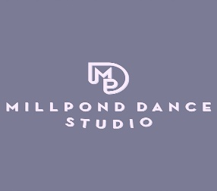

At Millpond Dance Studio, we are following strict social distancing and cleaning protocol. As any other public place, we cannot guarantee that you or your child will not be exposed (whether at MPD or elsewhere) or if exposed, that your child/self will not contract the disease.
By signing below, you agree to waive any claims of liability against MPD and to hold MPD harmless if you or your dancer contracts COVID-19 despite our best efforts to prevent it.
Additionally, you agree to notify MPD if you or your child or any member of your household contracts COVID-19 or has come into contact with someone who tested positive for COVID-19. This action will help ensure the utmost safety of our dancers and staff.
Thank you!
Kim Ferretti and Staff

Dancer’s Name(s)______________________________________________________________________

Parent/Self (over 18 dancer) Printed Name_______________________________________________________________________________

Parent/Self (over 18 dancer) Signature____________________________________________________________________________

Date_______________

